MEMBERSHIP APPLICATION

Date : __________________

DR. MICHAEL BAUTISTA BAYLON, L.SEAD
2026 President
Structural Engineers Association of Davao, Inc.

Attn: ENGR. LAZARO DE GUZMAN RIOFERIO, L.SEAD
Chairman, General Membership

Dear Sir,

I formally submit my intention to join the organization founded by its Vision and Mission for the advancement of the members through the continuing professional development program and make significant contributions to the community using the learning gained therein.

With pleasure, I would be willing to undergo an interview for knowledge verification with the Membership Committee as part of my application's qualifying process.

Attached is a copy of my membership profile and other supporting documents for your perusal and reference. I look forward to your favorable action on this request.

Very truly yours,

Name : _________________________

Email Address : _________________________
Mobile No. : _________________________

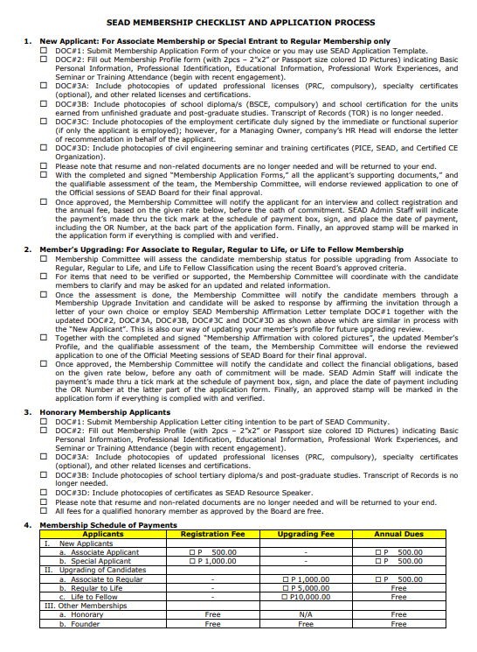


VISAYAS CHAPTER
No. 002

MEMBERSHIP PROFILE
Name
Name | First Name |  | Middle Name |  | Family Name
Address
Address | Lot/Block/ Bldg No., Street |  | Subd./Village/ City/Municipality |  | Province/Country (if Alien)
Personal Details
Personal Details | Birthdate: Month/Day/Year |  | Sex | Civil Status | Nationality |  | 2”x 2” Colored Photo
Contact Details
Contact Details | Landline Phone No.  (Country Code, Area Code, Phone No.) |  | Mobile Phone No.  (Country Code, Area Code, Phone No.) |  | Email Address  (Name, @ <gmail/Yahoo/etc>Extension.) |  | Messenger Account
Professional Identification  (Begin with PRC, then Specialty or other related engineering ID). | Licenses/Certificates |  | Registration No. |  | Year Registered |  | Expiration Date
Please write down all your professional identifications with corresponding photocopies of stated professional licenses (PRC CE mandated), specialty certificates, and other related engineering identifications.
Educational Information (Begin with the highest educational achievement) | Degree |  | Academic Institution |  | Location |  | Inclusive Years
Please write down all your educational achievements with the corresponding photocopies of the diploma (BSCE mandated), and school certification for the Post Graduate studies of units earned.
Professional Work Experiences (Begin with the recent or highest position in the institution) | Position |  | Company/Institution |  | Location |  | Inclusive Years
Please write down all your work experiences with the corresponding employment certificate duly signed by your immediate or functional superior or HR Head if the applicant is the owner of the company. For self-employed, please secure an endorsement from the project owner or representative.
Seminar or Training Attendance (Write SEAD or Joint with SEAD seminar or training participation). | Title |  | Organization |  | Participation |  | Year Attended
Please write down all the engineering seminar or training attended with the corresponding photocopies of the certificates.
Signature |  |  |  |  | Date:

